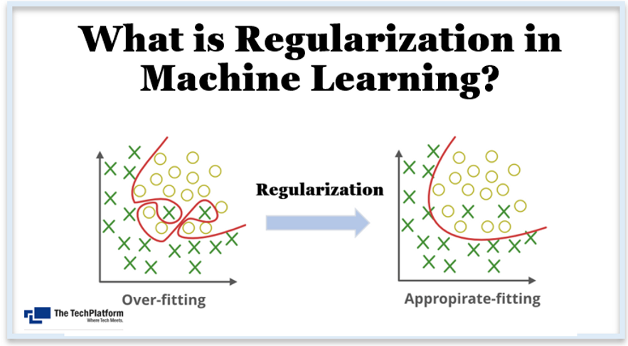

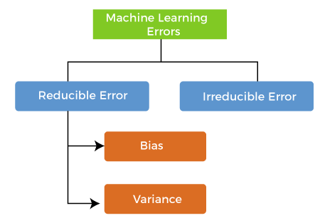

Bias

While making predictions, a difference occurs between prediction values made by the model and actual values/expected values, and this difference is known as bias errors or Errors due to bias.

Variance

The variance would specify the amount of variation in the prediction if the different training data was used. In simple words, variance tells that how much a random variable is different from its expected value.

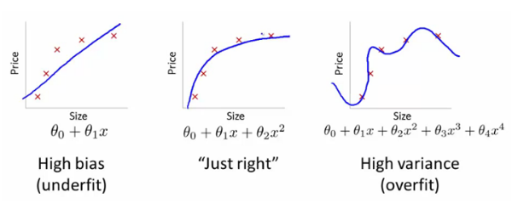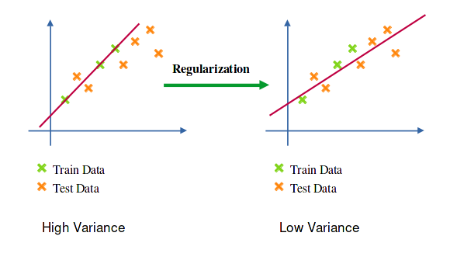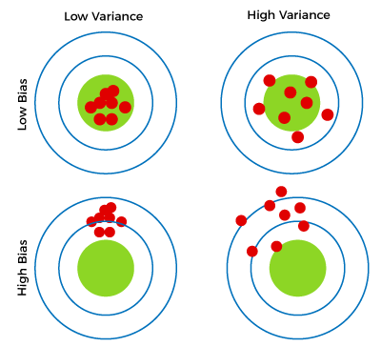

Lasso Regression
A regression model which uses the L1 Regularization technique is called LASSO(Least Absolute Shrinkage and Selection Operator) regression. Lasso Regression adds the “absolute value of magnitude” of the coefficient as a penalty term to the loss function(L). Lasso regression also helps us achieve feature selection by penalizing the weights to approximately equal to zero if that feature does not serve any purpose in the model.


where,
- m – Number of Features
- n – Number of Examples
- y_{i} – Actual Target Value
- y_{i}(hat) – Predicted Target Value]
- lamda- hyperparameter (used for fine tuning)

Ridge Regression
A regression model that uses the L2 regularization technique is called Ridge regression. Ridge regression adds the “squared magnitude” of the coefficient as a penalty term to the loss function(L).

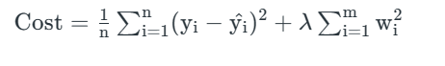

Elastic Net Regression
This model is a combination of L1 as well as L2 regularization. That implies that we add the absolute norm of the weights as well as the squared measure of the weights. With the help of an extra hyperparameter that controls the ratio of the L1 and L2 regularization.
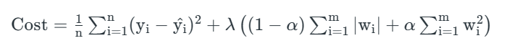

Benefits of Regularization
- Regularization improves model generalization by reducing overfitting. Regularized models learn underlying patterns, while overfit models memorize noise in training data.
- Regularization techniques such as L1 (Lasso) L1 regularization simplifies models and improves interpretability by reducing coefficients of less important features to zero.
- Regularization improves model performance by preventing excessive weighting of outliers or irrelevant features.
- Regularization makes models stable across different subsets of the data. It reduces the sensitivity of model outputs to minor changes in the training set.
- Regularization prevents models from becoming overly complex, which is especially important when dealing with limited data or noisy environments.
- Regularization can help handle multicollinearity (high correlation between features) by reducing the magnitudes of correlated coefficients.
- Regularization introduces hyperparameters (e.g., alpha or lambda) that control the strength of regularization. This allows fine-tuning models to achieve the right balance between bias and variance.
- Regularization promotes consistent model performance across different datasets. It reduces the risk of dramatic performance changes when encountering new data.
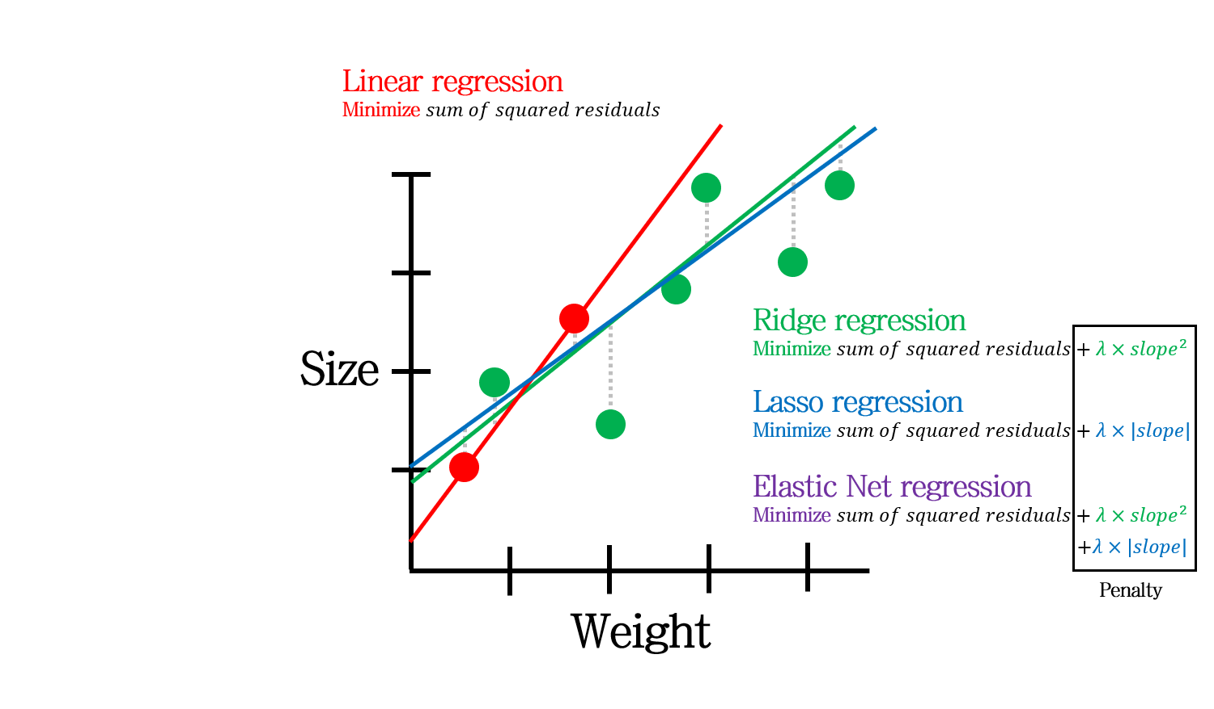

Dropout
Dropout is a regularization technique used in neural networks. It prevents complex co-adaptations from other neurons.
In neural nets, fully connected layers are more prone to overfit on training data. Using dropout, you can drop connections with 1-p probability for each of the specified layers. Where p is called keep probability parameter and which needs to be tuned.
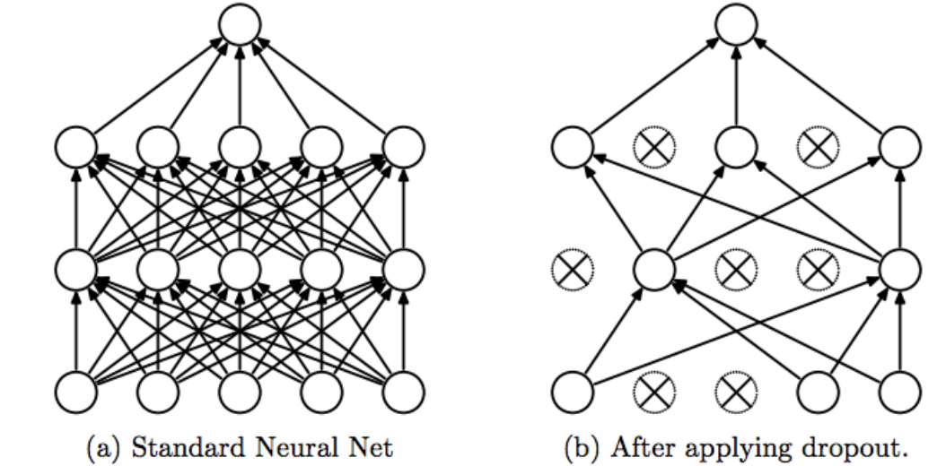
Early Stopping

In Regularization by Early Stopping, we stop training the model when the performance on the validation set is getting worse- increasing loss decreasing accuracy, or poorer scores of the scoring metric. By plotting the error on the training dataset and the validation dataset together, both the errors decrease with a number of iterations until the point where the model starts to overfit. After this point, the training error still decreases but the validation error increases.
So, even if training is continued after this point, early stopping essentially returns the set of parameters that were used at this point and so is equivalent to stopping training at that point. So, the final parameters returned will enable the model to have low variance and better generalization. The model at the time the training is stopped will have a better generalization performance than the model with the least training error.
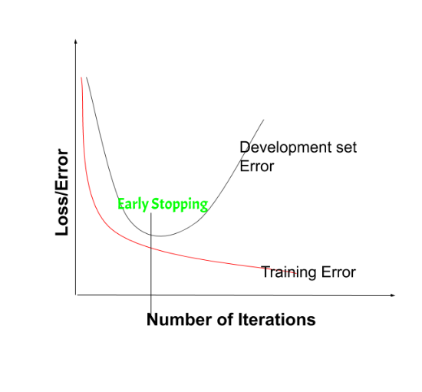
on the validation set is getting worse- increasing loss or decreasing accuracy or poorer scores
Early stopping can be thought of as implicit regularization, contrary to regularization via weight decay. This method is also efficient since it requires less amount of training data, which is not always available. Due to this fact, early stopping requires lesser time for training compared to other regularization methods. Repeating the early stopping process many times may result in the model overfitting the validation dataset, just as similar as overfitting occurs in the case of training data.
The number of iterations(i.e. epoch) taken to train the model can be considered a hyperparameter. Then the model has to find an optimum value for this hyperparameter (by hyperparameter tuning) for the best performance of the learning model.

Benefits of Early Stopping:
- Helps in reducing overfitting
- It improves generalisation
- It requires less amount of training data
- Takes less time compared to other regularisation models
- It is simple to implement

Limitations of Early Stopping:
- If the model stops too early, there might be risk of underfitting
- It may not be beneficial for all types of models
- If validation set is not chosen properly, it may not lead to the most optimal stopping
Data Augmentation:
- Increasing the size and diversity of the training set by applying transformations such as rotation, scaling, cropping, etc., to the input data.
- Helps the model to generalize better by exposing it to a wider variety of data.
Pruning:
- Removes unnecessary connections (weights) in a neural network after training.
- Helps to reduce the model's size and computational complexity while maintaining performance.

